## 1.1: Data Query Language

**1.** Retrieve the details (Name, Salary and dept code) of the employees who are working in department 20, 30 and 40.

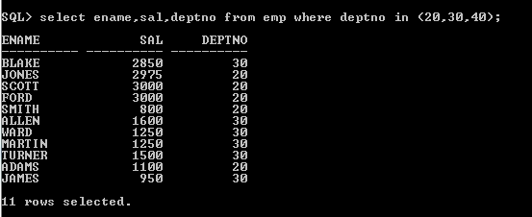

**2.** List the details of the employees with user defined Column headers.

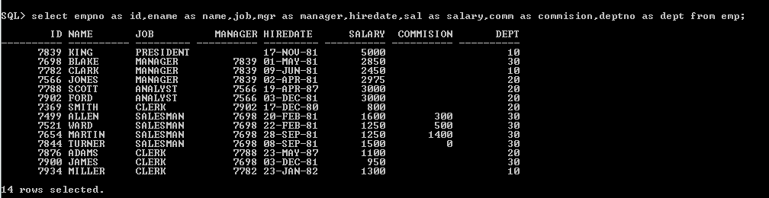

**3.** Display the code, subjects and total marks for every student. Total Marks will be calculated as Subject1+Subject2+Subject3. (Refer Student_Marks table)

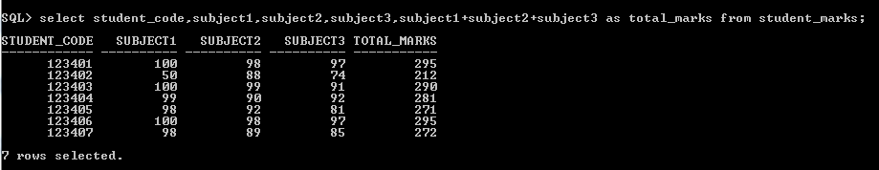

**4.** List the details of the staff whose designations are either PROFESSOR or LECTURER.



**5.** List the code, name, and department number of the employees who have experience of more than 18 years.

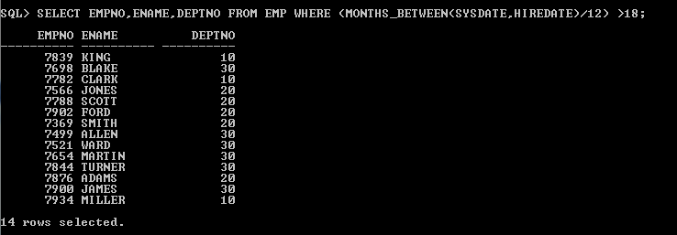

**6.** List the name and Designations of the staff who have joined before Jan 2003.



**7.** List the name, designation, and income for 10 years of the employees who are working in departments 10 and 30.

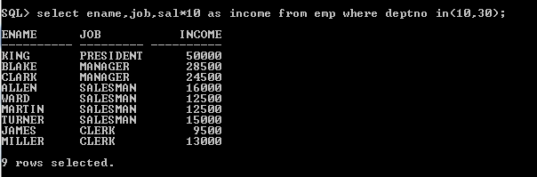

**8.** List the name and experience (in years) of employees who are working as LECTURER.



**9.** Display name concatenated with dept code separated by comma and space. Name the column as ‘Student Info’.

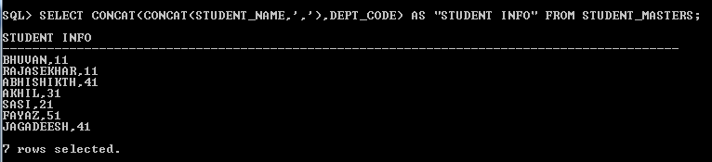

**10.** List the Name and Salary of the staff who are earning between 12000 and 25000. Sort them based on their salaries and name.

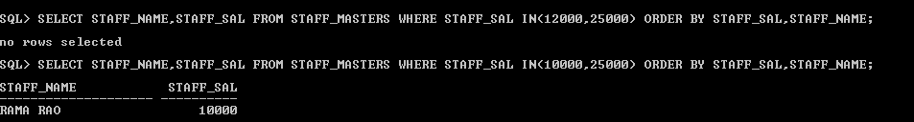

**11.** Display employees who do not have manager.

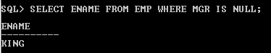

**12.** Write a query which will display name, department code and date of birth of all students who were born between January 1, 1981 and March 31, 1983. Sort it based on date of birth (ascending).



**13.** Get the Department number, and sum of Salary of all non managers where the sum is greater than 20000.

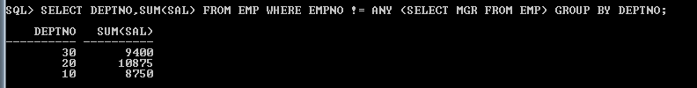

**14.** Display the details of books that have not been returned and expected return date was last Monday.



15. Display the name an**d** department code of students. If student does not belong to any department, display “No Department”. Label the column as “Department”. (Hint: Use NVL function)

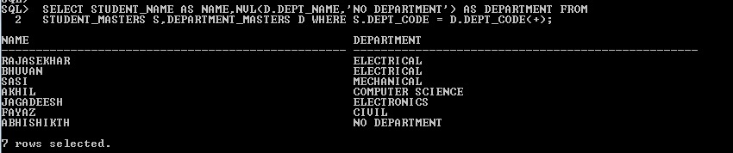

16. Display the name and salary of the staff. Salary should be represented as X. Each X represents a 1000 in salary.

Sample Output

JOHN 10000 XXXXXXXXXX

ALLEN 12000 XXXXXXXXXXXX

